Cranes Loads

Middle span Crane loads :   
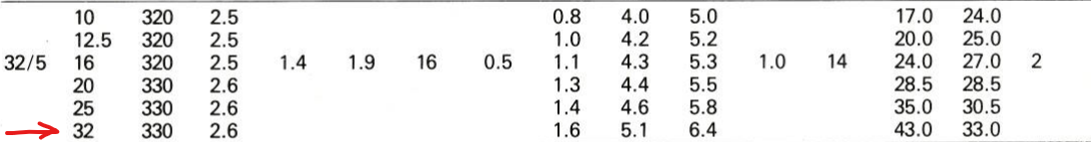  
  
crane own weight : (38 / 32 ) * 33 = 40 t

**Max wheel load = 40 t**

**Minimum Wheel load** = 40t * Wcrane ow / Wtotal = 40 * 43 / (43 + 32 + 14 ) = **19 t**

**Max Lateral shock =** 0.1 * 40t = **4 t**

**Min Lateral shock =** 0.1 * 19 = **1.9 t**

Left span crane loads :

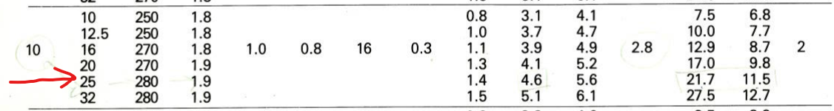  
**Max wheel load : 11.5 t**

**Minimum Wheel load** = 11.5t * Wcrane ow / Wtotal = 11.5*21.7/(21.7+2.8 + 10 ) = **7.2t**

**Max Lateral shock =** 0.1 * 11.5t = **1.15 t**

**Min Lateral shock = 0.72 t**

Corrugated Sheets

roof Corrugated sheets :

**Middle span Live load** = 60 – 200/3 * tan(α) = 60 – 200/3 * 0.06 = 56 kg / m2

* use corrugated sheet of allowable live load = 100 kg / m­2 , span **2 m**  
  use **continuous** corrugated sheet of thickness **0.55 mm**
* Ow Dead Load = 5.25 kg/m2
* **Total load Gravity** = 5.25 + 56 = **61.25** kg/m2
* **Wind Load** ( wind side )= q * c * K * a / cos(angle) = 50kg/m2 * -0.8 * 1.15 / cos(tan-1(1200/20000) ) = -**46 kg/m2**
* **Wind Load** ( wind opposite side )= q * c * K * a / cos(angle) = 50kg/m2 * -0.5 * 1.15 / cos(tan-1(1200/20000) ) = -**29 kg/m2**

**side spans live load** = 60 – 200/3 * tan(α) = 60 – 200/3 * 0.1 = 53 kg / m2

* use corrugated sheet of allowable live load = 100 kg / m­2 , span **2.5 m**
* use **continuous** corrugated sheet of thickness **0.7 mm**
* ow = 6.66 kg/m2
* **Total load =** 6.66 + 53 = **60** kg/m2
* **Wind Load** = q * c * K * a / cos(angle) = 50kg/m2 * -0.8 * 1.15 / cos(tan-1(1200/12500) ) = -**46 kg/m2**
* **Wind Load** ( wind side )= q * c * K * a / cos(angle) = 50kg/m2 * -0.5 * 1.15 / cos(tan-1(1200/20000) ) = -**29 kg/m2**

side Corrugated sheets :

**level > 10 m ,** Span = 2 m

* wind load ( wind direction ) **=** Ce * K * q = 0.8 * 1.15 * 50 = 50 kg / m2 ,
* Wind load ( opposite wind direction ) = **=** Ce * K * q = -0.5 * 1.15 * 50 = -**32 kg / m2**  ,
* Ow = 4.75 kg/m2 (vertical load)
* Use **continuous** corrugated sheets for all side of thickness **0.5 mm**

**level < 10 m ,** Span = 2.5 m

* Use corregated sheet of allowable load = 50 kg / m2
* **wind load** ( wind direction ) **=** Ce * K * q = 0.8 * 1.0 * 50 = 40kg/m2
* **wind load** ( wind opposite dir. ) **=** Ce * K * q = -0.5 * 1.0 * 50 = -25kg/m2
* Ow = 4.75 kg/m2 (vertical load)
* Use **continuous** corrugated sheets for all side of thickness **0.5 mm**

Corrugated Sheets Summery :

* Use continuous in **middle span** roof corrugated sheets of **0.7 mm**
* Use continuous in **side spans** roof corrugated sheets of **0.55 mm**
* Use continuous in **side corrugated** sheets of **0.50 mm**

Mezanin

Flooring = 200 kg/m2

Storage Floor Live Load = 500 Kg/m2

Management Floors Live Load = 400 Kg/m2

Walls distributed load = 200 kg/m2

Deck span = 2.50 m

Use Metal Deck thickness = 1.2 mm

For **Storage Floor** Use concrete thickness = 8 cm

* concrete load = 2500 kg/m3 * 0.08 = 200 kg/m2
* total dead load = 600 kg/m2
* total live load = 500 kg/m2
* total working load = 1100 kg/m2
* Total ultimate load for storage floor = 1.4 * (200 + 200 + 200 ) + 1.6 * 500 = 1640 kg/m2
* Allowable load for storage floor = **1758 kg/m2**

For **management Floor** Use concrete thickness = 7 cm

* concrete load = 2500 kg/m3 * 0.08 = 200 kg/m2
* total dead load = 575 kg / m2
* total live load = 400 kg/m2
* total working load = 975 kg/m2
* Total ultimate load for mang. floor = 1.4 * (200 + 175 + 200) + 1.6 * 400 = 1445 kg/m2
* Allowable load for management floor = **1542 kg/m2**

Mezanin Summery :

Use Metal Deck of **1.2 mm**

For Management Floors , Concrete Thickness = **7 cm**

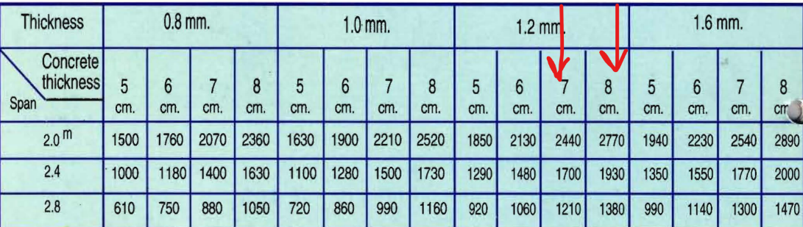For storage Floor , Concrete Thickness = **8 cm**

**Purlins Design**

**Purlins Middle span :**

* **Live** load = 56 kg/m­2 * 2m = **112 kg/m**
* Ow = 25 kg/m
* **Dead** load = 5.25 kg/m2 * 2m + 25kg/m = **30.5** kg/m
* Dead Load Reactions = 30.5kg/m * 6m / 2 = 91.5 kg = 0.092t
* Live load Reactions = 112kg/m * 6m / 2 = 336 kg = 0.34t
* Total load Reactions = 427.5 kg = 0.43 t
* Wind Load ( wind direction ) Reaction = -46kg/m2 * 2m * 6m /2 = -0.28t
* Wind load (opposite wind dir) Reaction = -29kg/m2 * 2m * 6m /2 = -0.18t

**Purlins Side Spans :**

* **Live** Load = 53 kg/m2 * 2.5m = **132.5 kg/m**
* Ow = 25 kg/m
* **Dead** Load = 25kg/m + 6.66kg/m2 * 2.5m = **41.65 kg/m**
* **Dead** load **Reactions** = 41.65kg/m * 6m / 2 = 125 kg = 0.125 t @ 2.5m span
* **Live** load **Reactions** = 132.5kg/m * 6m / 2 = 397.5 kg = 0.4t @ 2.5m span
* Total load = 0.525t
* Wind Load ( wind direction ) Reaction = -46kg/m2 * 2.5m * 6m /2 = -0.35t
* Wind load (opposite wind dir) Reaction = -29kg/m2 * 2.5m * 6m /2 = -0.22t

**Side Purlins Beams < 10.00 m level:**

* Wind Lateral Load (wind direction) = 40kg/m2 * 2.5m = 100kg/m = 0.1 t/m
* Wind Lateral Load (opposite wind dir) = -25kg/m2 * 2.5m = 63kg/m = 0.063 t/m
* Vertical load = corrugated sheet ow + purlin ow = 4.75 kg/m2 * 2.5m + 25kg/m = 36.9kg/m
* Lateral Reaction (wind direction) = 0.1t/m * 6m / 2 = 0.3t
* Later reaction (opposite wind dir ) = 0.063t/m * 6m /2 = 0.19 t
* Vertical Reaction = 36.9kg/m * 6m / 2 = 0.11t

**Side Purlins Beams > 10.00 m level:**

* Wind Lateral Load (wind direction) = 46kg/m2 * 2 m = 92kg/m = 0.092 t/m
* Wind Lateral Load (opposite wind dir) = -32kg/m2 * 2 m = 64kg/m = 0.064 t/m
* Vertical load = corrugated sheet ow + purlin ow = 4.75 kg/m2 * 2 m + 25kg/m = 35kg/m
* Lateral Reaction (wind dir) = 0.092t/m * 6m / 2 = 0.28t
* Lateral Reaction (opposite wind dir) = 0.064t/m * 6m / 2 = 0.19t
* Vertical Reaction = 35kg/m * 6m / 2 = 0.11t

**Beams load**

**Mezanin storage floor main beams** (using metal deck allowable load ) :

* Dead load = 1.6t/m * 6m = 9.6 t , secondary beams from one side , @2.5m spacing
* Live load = 1.25t/m * 6m = 7.5 t , secondary beams from one side , @2.5m spacing

**Mezanin management floor main beams** (using metal deck allowable load ) :

* Dead load = 1.55t/m * 6m = 9.3 t, secondary beams from one side , @2.5m spacing
* Live load = 1t/m * 6m = 6 t , secondary beams from one side , @2.5m spacing

**Mezanin Storage Floor Secondary Beams :**

* Dead load = 0.6t/m2 * 2.5m = 1.5 t/m
* Total Live load = 0.5t/m2 * 2.5m = 1.25 t/m
* ow = 100 kg / m
* Total Dead load = 0.1t/m + 1.5t/m = 1.6 t/m

**Mezanin Management Floor Secondary Beams :**

* Dead load = 0.58t/m2 * 2.5m = 1.45 t/m
* Ow = 0.1 t/m
* Total Dead load = 1.55 t/m
* Live load = 0.4t/m2 * 2.5m = 1 t/m

**Frame girder load :**

* Purlins concentrated **Dead** loads from each sides= 2 * 0.125t = **0.25t** ,9purlins@2.5m
* Purlins concentrated **Live** loads from each sides = 2 * 0.4t = **0.8t** ,9purlins@2.5m
* Utilities **Dead** loads = **0.1 t /m**

**Truss loads :**

* Purlins concentrated **Dead** loads at nodes from each sides = 2* 0.092t = **0.185t** ,purlins@2.5m at each node
* Purlins concentrated **Live** loads at nodes from each sides = 2* 0.34t = **0.68t** ,purlins@2.5m at each node
* Utilities **Dead** Load = 100 kg / node = **0.1t** /node